Dear Valued Guest  Thank you for choosing our resort as a destination of your vacation Please allow us to share with you our Hard All-Inclusive Package especially created for your convenience  What is included?  Breakfast  Start your day with our lavish Breakfast Buffet at the Main Restaurant  Early Continental Breakfast  From 6.00 A.M Till 7.00 A.M  Buffet Breakfast  From 7.00 A.M Till 10.00 A.M  Morning Snacks  For those who had a long night and wake up late served at the terrace  From 10.30 A.M Till 11.00 A.M  Lunch  Served at the Main Restaurant from 13.00 till 15.00  Light Snacks  Hot snacks served at the Beach Food Court  From 13.00 Till 17.00  Ice Cream  From 16.00.Till 17.00 at the Terrace bar  Dinner  Served at the Main Restaurant from 18.30 till 21.30 | 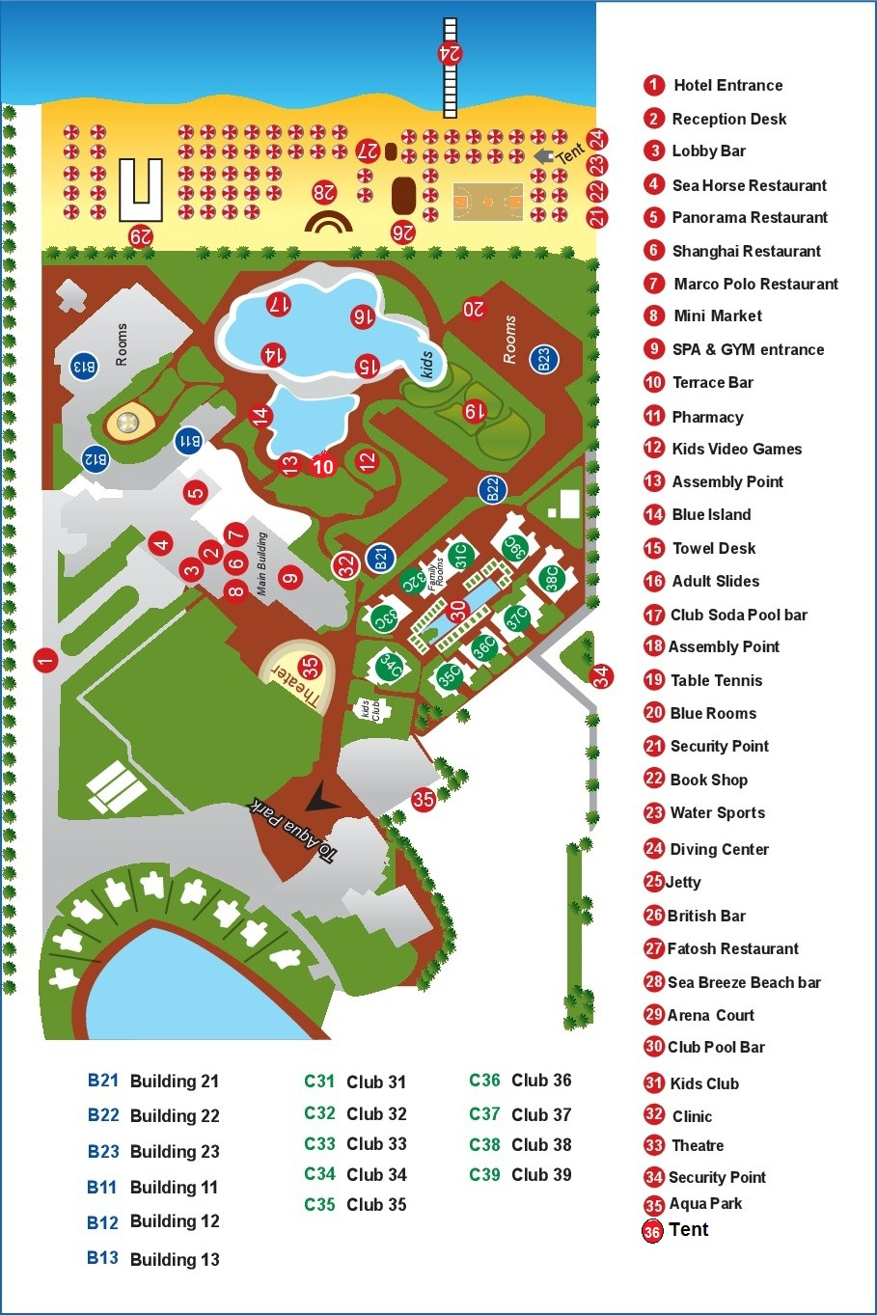 | Ala Cart Dinner  Dinner at the All Carte Restaurants once per stay subject to the availability reserve your seat for ala carte restaurant Italian or Chinese or Lebanese please contact the guest relation  Kids Menu  Kids buffet corner at main restaurant during the Lunch & Dinner and at Kids club 11:00-12:30  Vegetarians & Food allergic  For those who are vegetarians and those who had food allergic for any food items please contact the guest relation at the reception  Beverages will be served all day long  All beverages served in glasses, one glass per time  Terrace Bar from 10.00 A.M till 00.00  Beach Bar from 10.00 A.M till 17..00  Aqua Park Bar from 10.00 A.M till 17.00 soft drink only  Mineral water, soft drinks, juices, tea, coffee, local spirits, local beer & alcoholic cocktails  Red & White wine will be served during the lunch & dinner  one alcoholic cocktails during the Disco time Jolie Pub Bar  please contact the chef animation  Items are not included  Lobby bar Jolie Pub, Espresso, Cappuccino, fresh Juices, Turkish coffee, Shisha, Imported spirits, Any drinks by bottles, Mini bar, Room Service, Telephone, House doctor, Diving center, water sports, Horse riding, Video games, billiard table, Spa, Sauna, Jacuzzi, Massage, Hairdresser and Beauty salon  Telephone Directory  Reception & Operator 0  Guest relation 5  Concierge 4  Housekeeping 23  Clinic 20

